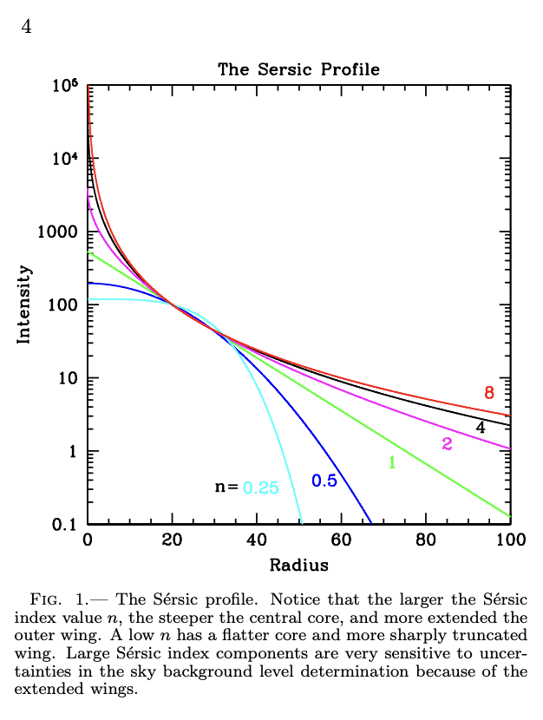

This figure is from the Galfit User’s Manual, a tool we’re using in my project to determine light information about galaxies. Galfit manages equations that synthetically try to model what the 2D light profiles of galaxies should look like based on images we provide it. It does this to better understand how light is distributed in galaxies so we can more accurately determine the effective radii, or sizes, of given galaxies. “The Sersic Profile” is one of the equations Galfit uses. This specific figure shows how the Sersic profile finds a relationship between brightness (or intensity) and radius from the galaxy’s center. Specifically it shows us that as you get further away from the center of a galaxy, you observe less and less of its light. But as you’ll notice, not all of these lines are the same, and that’s because light at low and high radii behave differently depending upon the compactness of light at the centers of these galaxies. Core compactness, or N, is used in the Sersic profile to describe these more compact galaxies. And as you can see this N value significantly changes how light is distributed as you get further away from the galaxy center. What this relationship on this figure essentially then tells us is that galaxies with more compact and brighter cores have brightness drop offs that take longer than galaxies with less compact cores. For a galaxy with n = 0.25, for example, you’ll notice a sharper drop-off in intensity as the radius increases to around 50, than you will with a galaxy with an n value of 8 that’s light extends a longer distance. Without the ability to change variables such as N that exist in equations such as the Sersic profile, we’d be unable to accurately determine the true light distribution and size of galaxies past the more noisy space that they extend into. This program adjusts variables like the N seen in this figure to more accurately describe how light is being distributed beyond what telescopic images can originally determine. This is useful because ultimately the equations that correspond to these relationships help us to better determine galaxy size, and in at the same time, help us to solve if there is a relationship between galaxy size and the production efficiency of ionizing photos, a primary question in my and my mentor’s project.